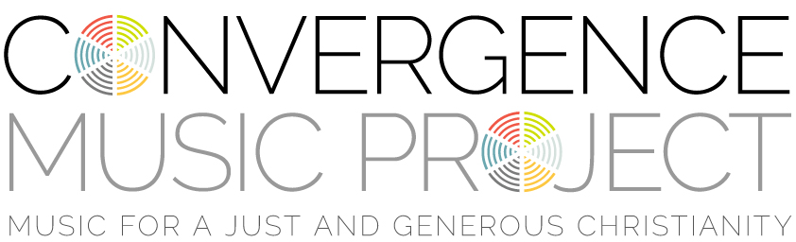

Kindness
Words & Music by Brian McLaren
Copyright 2013, The Restoration Project. All Rights Reserved.

Christ has no body here but ours
No hands and feet here on earth but ours
Ours are the eyes through which Christ looks
On this world with kindness.

Ours are the hands through which God works
Ours are the feet on which God moves
Ours are the voices through which God speaks
To this world with kindness

Through our touch, our smile, our listening ear
Embodied in us, Jesus is living here …

So let us go now,
Filled with the Spirit,
Into the world with kindness.

