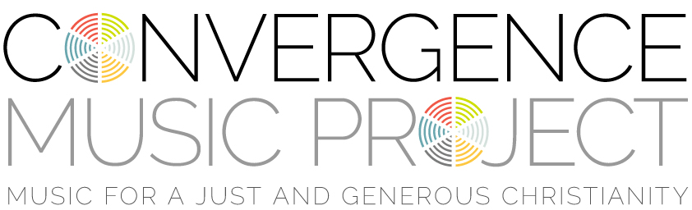

’ROUND THE TABLE
Words and Music by Larry Olson & Hans Peterson
©2002 Dakota Road Music.
All rights reserved. Used by permission.

Come together 'round the table
come and taste the wonder
A healing touch and a deep connection
from the living center of it all
Seeking meaning on the run
you try and save the day
but all is ready, will you come?
love invites the way (Chorus)
Bring a friend or enemy
or one you hold or blame
With each other we are one
here in Jesus' name (Chorus)
Hear creation groan for life
will hate and hunger cease?
In the roar of violence
the world cries for peace (Chorus)

